1. 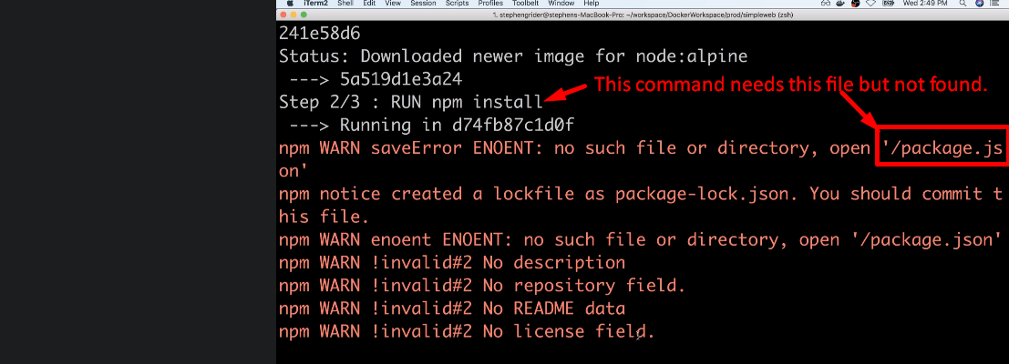
2. 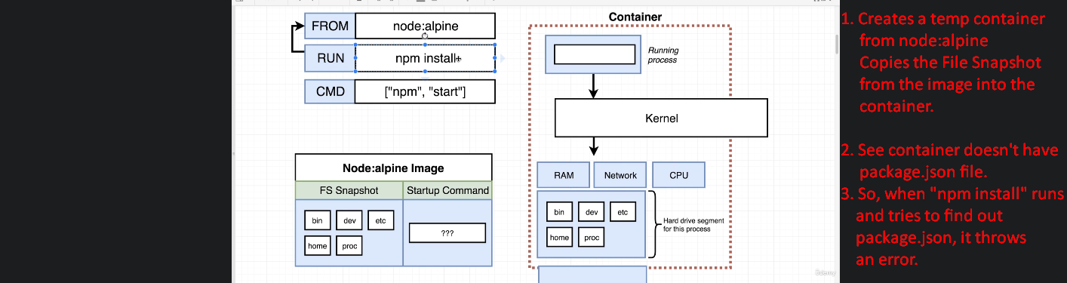  
   If the above is not clear, go back to the previous lecture.